EPCA Report No. 32 (March 2007)

Controlling pollution from the growing number of diesel cars in Delhi
In the matter of W.P. (C) No.13029 of 1985; M.C. Mehta v/s UOI & others

- The Hon’ble Supreme Court has taken important initiatives to clean Delhi’s air. Over the past few years, these efforts have led to improvement, with quantifiable impacts on air pollutants – carbon monoxide, lead and sulphur dioxide. The levels of respirable particulate matter (RSPM) has decreased and stabilised during this period. But the trends are now getting reversed. Levels of two key pollutants – RSPM and nitrogen oxides (NOx) – are on the rise. It is imperative that urgent action is taken to reverse the situation, otherwise the gains made will be negated.
- Based on this imperative, EPCA has deliberated on a number of strategies to control pollution, from better maintenance of in-use vehicles; introduction of better emission control in existing and new fleets of commercial vehicles, on upgrading the public transportation network in the city and building bypasses for transit vehicles. But even with all these measures in place, it is clear that the increase in the numbers of private vehicles and particularly, the increase of diesel fuelled personal vehicles, needs to be addressed.
- EPCA has taken stock of the increased dieselisation of vehicle fleet in the city. It is concerned that is contributing to the pollutants, of most concern to the city, namely RSPM and NOx.
- EPCA is also concerned that this growth of personal diesel vehicles is threatening to undo the work done through the initiatives of the Hon’ble Court, to reduce pollution in the city by phasing out diesel buses and converting them to CNG. It is estimated that even at a very conservative estimate, the total number of diesel cars presently in Delhi is equivalent to adding particulate emissions from nearly 30,000 diesel buses.
- EPCA is also concerned that this drive for dieselisation is being driven by prices of the fuel, which keep it much lower than petrol. While the prices are kept depressed for reasons of social justice and to meet the needs of the poor, car manufacturers are using this opportunity to expand their diesel variants.
- In this report, EPCA has reviewed global practice regarding diesel; health concerns and technology and fuel options.
- Based on these findings, EPCA seeks directions from the Hon’ble Supreme Court.

Environment Pollution (Prevention & Control) Authority
for the National Capital Region

1. Background

The Environment and Pollution (Prevention and Control) Authority (EPCA) is extremely concerned by the rapid increase in the numbers of diesel cars in Delhi because it poses an urgent pollution challenge. Key air toxins -- particulate matter and nitrogen dioxides -- related to diesel emissions are rising alarmingly in the city. Diesel particulates are particularly toxic and have been classified by the international regulatory and health agencies as possible carcinogens. EPCA is concerned that this increase in private diesel cars, encouraged by cheaper diesel fuel, is now threatening to negate benefits of the compressed natural gas programme in the city.

EPCA had first raised this issue in 1999 when dieselisation of the automobile fleet had just begun. In the late 1990s, even though the total share of diesel cars in the new sales of cars in Delhi was only 4 per cent, the customer response to the diesel models because of cheaper diesel fuel and the appearance of a large number of new diesel car models in the market signalled potential shifts in the car market. This prediction has come true. The share of diesel cars in the new car sales in Delhi has reached more than 24 per cent within a few years.

The issues related to the pollution impacts of diesel cars have been discussed by the Hon’ble Court. EPCA has been also submitted information and opinion on this matter. A quick summary of the key developments is as follows:

1999: EPCA had submitted report note to the Court on `Restriction on the plying of diesel-driven (private) vehicles in the NCR.’ This report asked for a ban on diesel cars in Delhi based on the emerging public health and science and pollution levels in Delhi. Based on this report, the Amicus Curiae filed an application for directions “to forthwith suspend registration of diesel vehicles until further orders.”

The Hon’ble Supreme Court order of April 16, 1999 noted the gravity of the situation and took “note of the effects of diesel exhaust on the health of citizen” and sought information about the number of diesel and petrol driven vehicles registered in NCR in 1997 and 1998 and thereafter.

In its report submitted in June 30, 1999, EPCA analysed the details of the particulate pollution problem in Delhi and the risks of diesel exhaust. EPCA also discussed the matter in length with the automobile industry. EPCA noted in its report that regardless of numbers of diesel cars, the vehicles emitted the most toxic polluting component of the tiny particulates – Respirable Suspended Particulate Matter (RSPM) It upheld its earlier contention that “the registration of new diesel driven private passenger vehicles should be banned, as this will cause the expansion of the pollution problem by creating a new use of diesel.”

These developments lead to court directions of April 29, 1999 that advanced the enforcement of Euro II emissions standards by five years. However, this order, did not anticipate the transition to diesel, which would negate its directions to move buses to CNG.

2001: The Hon’ble Supreme Court vide its order dated March 26, 2001 directed:
“During the course of argument, it was contended before us that low sulphur diesel should be regarded as a clean fuel and buses be permitted to run on that. We direct the Bhure Lal Committee to examine this question and permit the parties to submit their written representations to the Committee in this behalf. The Committee may submit a report to this Court in that also indicates as to which fuel can be regarded as `clean fuel’, which does not cause pollution or is otherwise injurious to health”.

In July 2001, EPCA submitted the ‘Report on Clean Fuels’. The report recommended that hydrocarbon fuels are inherently polluting and hence such fuels cannot be regarded as ‘clean fuels’ and totally non-injurious to health. The effort should be to constantly improve the fuel and engine technology of automobiles to reduce emissions injurious to human health. However, among these fuels, gaseous fuels -- CNG, LPG and propane -- can be regarded as environmentally acceptable fuels in the NCT of Delhi. After detailed consideration and review of global experiences, EPCA concluded that in the pollution hot spot of Delhi, low sulphur diesel with 0.05 % (500 ppm) sulphur cannot be regarded as an environmentally acceptable fuel.

It instead recommended that ultra-low sulphur diesel with 0.001 % sulphur (10 ppm) and low PAH content in combination with after treatment devices like continuously regenerating traps (CRT) and catalytic converters could be regarded as environmentally acceptable fuel in the NCT of Delhi. But in addition, it was important that the fuel was not adulterated with low quality diesel or other adulterants. This quality of fuel is still not available in the country.

2004. EPCA on examining the action plans of polluted cities pointed out in its report: ‘The particulate pollution reduction strategy in seven critically polluted cities’ ‘while considering mitigation strategies it is not enough to consider only the quantum of pollution but also toxicity of emissions. Literature review shows that diesel vehicles contribute not only considerable amount of particulate from the transport sector but are also most toxic. Diesel particles have already been designated as toxic air contaminant and potential human carcinogen therefore should be minimized as drastically as possible.

With the spectre of increasing pollution in Delhi, it is critical to examine the issue once again. While public transport in Delhi has been effectively kept away from poor quality diesel, it is making a comeback through personal transport and is threatening to nullify the air quality gains. Delhi has phased out 12,000 diesel buses to escape from the lethal effect of toxic diesel particles. But even at a very conservative estimate, the total number of diesel cars in Delhi is equivalent to adding particulate emissions from nearly 30,000 diesel buses.

2. Rapid growth in diesel car numbers

Controlling pollution levels is turning out to be an enormous challenge because of the increase in the total vehicle numbers in Delhi. According to the Economic Survey of Delhi 2005-2006 during 1995-96 and 2005-06 the decennial growth rate is substantially higher in case of private vehicles (91.62 percent). The city added 963 personal vehicles each day on its roads in 2006, of which 308 vehicles were cars.

But the most worrying trend is the rapidly rising number of diesel cars in the city. In Delhi diesel cars have increased by nearly 425 per cent over the last decade. The total diesel fuel consumption that was lowered with the introduction of CNG during 2000-04 has begun to increase again.

According to the information from the Society for the Indian Automobile manufacturers (SIAM) the market share of diesel cars have already increased to over 30 per cent in the last 18 months. The share of diesel cars is expected to be 50 per cent of the total car sales by 2010. In Delhi, while petrol cars have increased at 8.5 per cent annually, diesel cars have maintained a growth rate of 16.6 per annum – just the double. In addition, the city gets huge inflow of traffic from surrounding areas – Gurgaon, Faridabad, Ghaziabad etc.

This overwhelming growth and traffic moving on diesel will be devastating as diesel vehicles are known to emit higher smoke, particles and NOx than their petrol counterparts. According to WHO and other international regulatory and scientific agencies diesel particulates are carcinogens.

Graph 1: Growth of diesel car, jeep and vans in Delhi

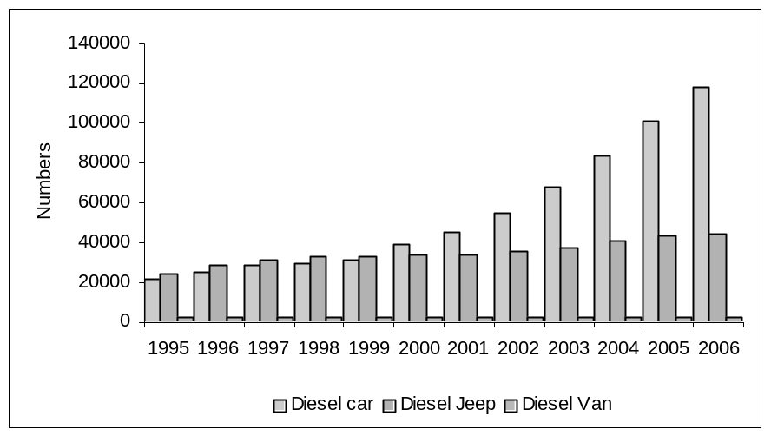
Source: Based on data provided by transport department, Government of National Capital Territory of Delhi, mimeo

3. The health implications of diesel vehicles

Diesel vehicles spew pollutants of most serious concern. While direct emissions of particulates and nitrogen oxides are very high, they also contribute significantly towards the build-up of secondary particulates and ozone. Diesel particulates are largely elemental carbon, which absorb toxic organic compounds. The particulate emissions from uncontrolled diesel engines are 6-10 times greater than those from petrol engines.

Diesel vehicles, however, emit lower carbon monoxide (CO) and hydrocarbons (HCs) compared to petrol vehicles, because diesel engines operate at lean air-to-fuel ratio. In the atmosphere some of the sulphur dioxide (SO₂) that comes from the vehicles, which is in direct proportion to the sulphur in the fuel, gets converted into sulphates and impacts on the ambient particulate levels in our cities. Similarly, diesel combustion produces very high amounts of nitric oxide (NO) that forms a major part of NOx emissions. This contributes to photochemical smog and, through secondary atmospheric transformation, to particulate aerosols.

The rise in numbers of diesel vehicles is very disturbing because deadly facts about diesel toxicity and evidence of the acute cancer-causing potential of diesel pollutants are pouring in from around the world. Diesel fumes have been found to emit more particles and NOx than petrol exhaust and are several times more toxic. Clean diesel solutions are still not available in India.

The International Agency for Research of Cancer (IARC), World Health Organisation (WHO), United States Environmental Protection Agency (US EPA), Health Effects Institute, California Air Resources Board (CARB), National Institute for Occupational Safety and Health have all classified diesel emissions as carcinogen.

CARB identified diesel exhaust in 1990 as a chemical known to the state to cause cancer and after an extensive review in 1998, listed diesel exhaust as a toxic air contaminant. More recently, the US National Institute for Environmental Health Sciences added diesel particulates to its list of substances that are reasonably anticipated to be human carcinogens in its ninth national toxicology report on carcinogens. In fact, a multiple air toxics exposure study (MATES II) conducted by the South Coast Air Quality Management District in California found that diesel particulates pose 70 per cent of the cancer risk in the basin or in southern California. Other toxics from vehicles like benzene, butadiene and formaldehyde represent 20 per cent of the risk, and stationary sources contribute about 10 per cent.

Several international and national health agencies have also reviewed relevant data on diesel exhaust and have classified either the exhaust mixture or the particulate component as probable human carcinogen (See Annexure: Health studies). The deadly truth about diesel exhaust is that it includes 40 different toxic compounds that cause cancer, reproductive abnormalities and other toxic impacts.

4. Contribution of diesel vehicles to air pollution in Delhi

Uncontrolled dieselisation can undo the past gains. Both PM and NOx levels in Delhi that are also related to diesel emissions are threatening to rise again. The contribution of diesel emissions to fine particulate matter, oxides of nitrogen and other carcinogens like polycyclic hydrocarbons should not be underestimated.

In India, rigorous emissions inventories have not been carried out to understand the impact of dieselisation on ambient air. A collage of small evidences, however, bears out the impact on air quality. A World Bank supported study on source apportionment of PM_{2.5} (particulate matter less than 2.5 micron in size) in selected Indian cities released in 2004 shows that, depending on the season, the contribution of diesel fuel to the total PM_{2.5} ambient concentration can be as high as 61 per cent in Kolkata, 23 per cent in Delhi and 25 per cent in Mumbai. The fine particulates have serious health consequences as per the health studies conducted in other countries.

Dire impact of dieselization on air quality is evident from studies conducted in other cities as well. A 2004 study carried out by Mario Camarsa, fuel and technology expert formerly with the UK-based Enstrat International Limited, has assessed the impact of low-sulphur diesel (LSD) fuel on diesel emissions in three Asian cities — Bangkok, Bangalore and Manila. This bears out the varying but growing trends in diesel emissions in these cities. In Bangalore, the Camarsa study found diesel engines to be a significant contributor of the total NOx emissions from vehicles — as much as 40 per cent — and comparatively less significant contributor of PM10.

The rising diesel pollution is also a concern in other Asian countries as well. In Bangkok, the Camarsa study estimated that diesel engines are responsible for as much as 77 per cent of NOx and 80 per cent of PM₁₀ from vehicular sources respectively. Other light-duty diesel vehicles and diesel buses are significant contributors of NOx. In Manila, diesel vehicles contribute as much as 25 to 40 per cent of the total mobile source emissions of NOx. The contribution of diesel cars is still low due to their fewer numbers. Similarly, all diesel vehicles contribute nearly 22 per cent of PM10 emissions from vehicular sources.

China has a small diesel car fleet and most of the diesel pollution is caused by the expanding fleet of heavy-duty vehicles. According to a study by vehicle technology expert Michael P Walsh, published in 2003, even in China there is a significant shift in fuel use due to higher diesel penetration, especially truck and bus fleets. This shift to greater use of diesel, while helpful from the standpoint of improving fuel economy, will put even greater pressure on urban air quality because of high NOx and PM emissions from these vehicles, the study assessed.

Even industrialised Japan is not without its worries. Diesel powers roughly one out of every six vehicles in Japan but these are estimated to emit nearly 100 per cent of the vehicle-related PM emissions. These also emit 75 per cent of the vehicle-related NOx emissions. The regional pattern is thus clear. Diesel vehicles are already significant contributors of PM and NOx pollution in Asian cities.

While in Delhi significant shift has happened towards compressed natural gas (CNG) as a vehicle fuel and currently more than 100,000 vehicles are plying on CNG. The impact has been clear on the particulate pollution in the air of the city.

In terms of particulate emission nearly four diesel cars are equal to one diesel bus as a Bharat Stage II compliant diesel bus emits 0.32 gm/km (as per a study by TERI 2004) and the norm for Bharat Stage II diesel car is 0.08 gm/km (Motor Vehicle Laws 2004). Therefore, the current fleet of around 1.18 lakh of diesel cars in Delhi are emitting particulates equal to around 29,658 diesel buses.

Similarly the NOx emissions are also several times higher in case of diesel cars. The emission data provided by the Automotive Research Association of India shared with Centre for Science and Environment shows that 2000 vintage diesel cars emit nearly 6 times higher NOx than petrol cars.

Graph 2: Petrol and diesel car emissions
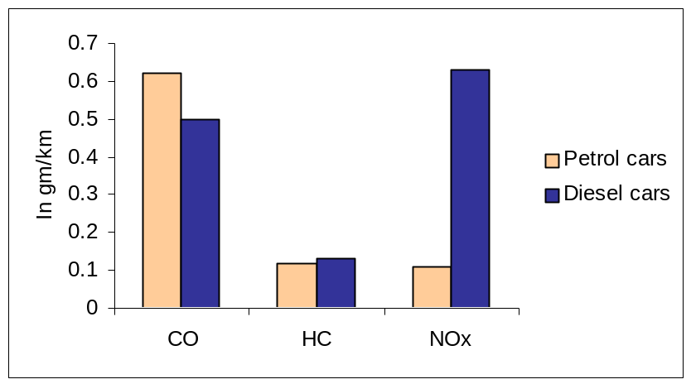
Note: model year 2000
Source: Emissions data provided by Automotive Research Association to Centre for Science and Environment, June 21, 2002, mimeo

This continued and increased use of diesel in the city is clearly contributing to pollution. The trend of NO_{2 ,} which is a measure of NOx, makes this clear (see graph). It is clear that diesel use is the key contributor, as NOx levels are rising in other Indian cities as well, where the numbers of these vehicles in increasingly disproportionately.

Graph 3: Nitrogen dioxide (NO₂) levels in Delhi 1998-2005
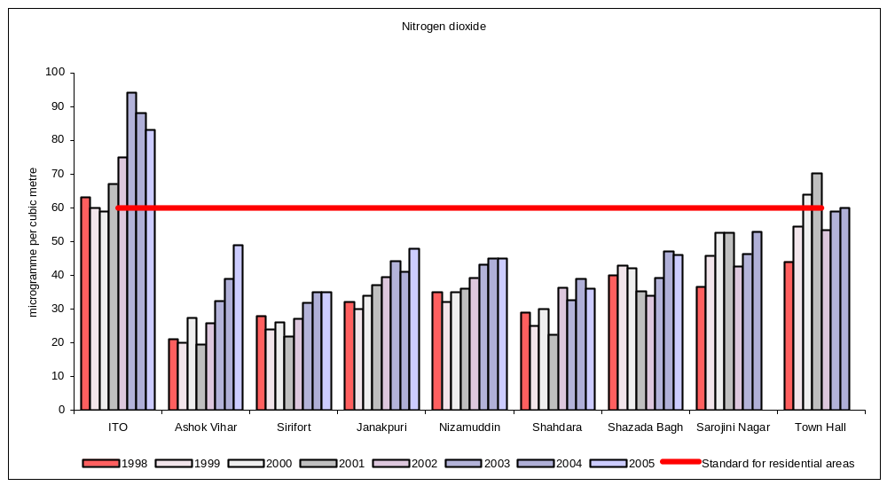
Note: Standard for residential areas is 60 microgramme per cubic metre
Source: Based on data provided by the Central Pollution Control Board, New Delhi

Graph 4: Respirable particulate matter (PM₁₀) levels in Delhi 2000 - 2005

Levels are stable but are extremely high
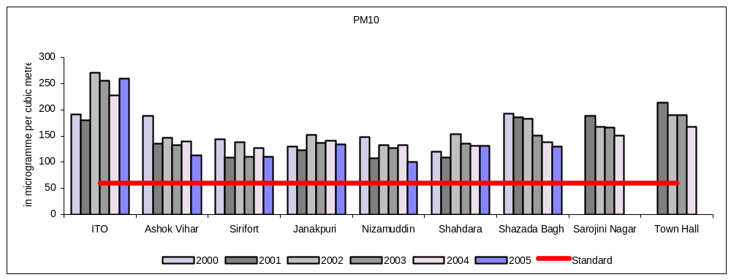
Note: Standard for residential areas is 60 microgramme per cubic metre
Source: Based on data provided by the Central Pollution Control Board

5. The state of Indian diesel emission regulations

Currently, in India, diesel vehicles have to comply with Euro II (Bharat Stage II) emission standards for vehicles sold in most cities and with Euro III (Bharat Stage III) emission standards for vehicles sold in 11 cities. Vehicle manufacturers argue that these emission regulations make their cars clean as they are more stringent than the past. Unfortunately, this is not quite correct.

The current emission standards are in fact, designed to allow diesel vehicles to emit higher pollutants than petrol vehicles. Even the Bharat Stage III standards, which are based on using diesel fuel with 350 ppm of sulphur allow higher limits for nitrogen oxides and particulate emissions compared to petrol cars.

As a result, in India diesel cars meeting these standards are ‘legally’ allowed to emit nearly three times more NOx than the comparable petrol cars and also several times more particulates. Petrol vehicles have negligible emissions of particulates, while every diesel car is allowed to emit 0.05 gm/km in the Bharat Stage III norms.

Petrol vehicles on the other hand are given higher standards for CO, as compared to diesel. The problem is that health concerns over diesel particulates are far greater and in Indian cities, in particular, particulate pollution is on the rise with devastating implications. (See graph 5: Diesels have unfair emission advantage in Indian norms).

Graph 5: Diesels have unfair emission advantage in Indian norms
Diesels are legally allowed to emit nearly three times more NOx in Bharat Stage III (Euro III equivalent)

(A) NOx norms for cars
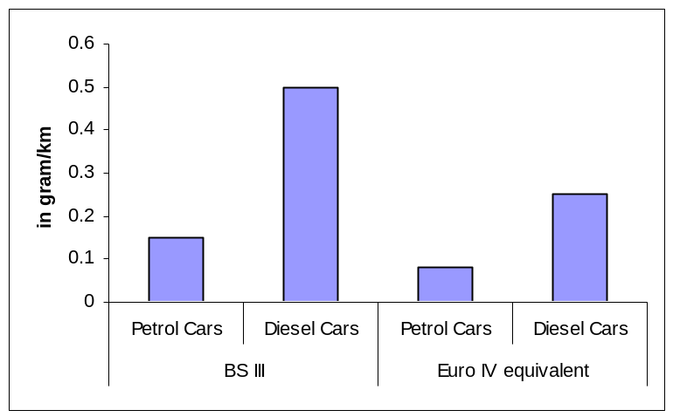
(B) PM norms for cars
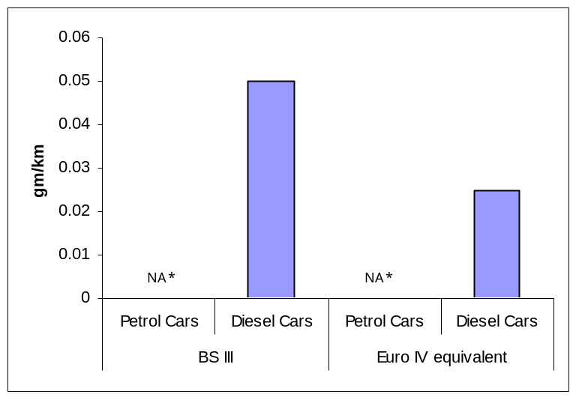
Note: * Mass PM emissions from petrol cars is considered negligible hence it is not regulated.
Bharat Stage III emission norm are equivalent to Euro III emissions norms
Source:
- Bharat Stage III emission norm: Anon 2004, Notification No G.S.R. 686 (E), dated 20th October 2004 – Bharat Stage III emission norms, Ministry of Shipping, Road Transport and Highways, Government of India
- Euro IV equivalent emission norm: Anon 2002, Report of the expert committee on Auto Fuel Policy, Government of India, New Delhi, August

The data available from Europe for urban traffic shows that diesel and petrol cars meeting the same level of emission norms have different toxicity levels. The toxicity is several times higher for diesel emissions even as the emission standards are progressively tightened. (See graph 6: Toxic profile of diesel and petrol cars meeting Euro norms; also followed by India).

Graph 6: Toxic profile of diesel and petrol cars meeting Euro norms
A comparison of toxicity of emissions from diesel and petrol passenger cars meeting different norms in urban traffic
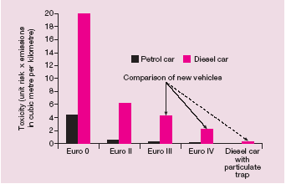
Source: Michael Walsh 2003, The global impacts of heavy-duty diesel vehicle emissions, USA, mimeo

6. The experience with diesel PUC for in-use vehicles

The problem is compounded by the fact that the emissions testing of the in-use diesel vehicles have remained ineffective across the world. The most common test, the smoke density tests for diesel vehicles as conducted under the pollution under control (PUC) programme are inefficient in checking emissions on the road. Therefore, not only is the diesel vehicle allowed to emit more but even its regulation on the road is difficult.

For instance, particulate matter is the key pollutant of concern because of its serious public health impacts. But its direct measurement from the in-use diesel fleet has not matured for wide commercial application across the world. The dominant testing method available for diesel is the smoke opacity test (free-acceleration smoke test) to calculate the density of the smoke emitted from diesel vehicles. But experts say that while these tests can at best check for major engine malfunction in old vehicles, these are not very effective in new engines that normally have low smoke levels. These modern diesel vehicles, which may not emit black smoke, have high fine particulate emissions. However, it is difficult to measure these particulate emissions on road and in pollution-under-control tests.

The current and uniform smoke opacity norm is 65 Hartridge smoke units (HSUs). This was not revised when the revised norms were notified by the Ministry of shipping, road transport, and highways in its notification of February 2004. It added engine speed and oil temperature measurements at the time of the smoke opacity tests to ensure that the smoke measurement is done on a sufficiently warmed up engine at the right engine speed. Smoke opacity standards for diesel cars in other countries are significantly tighter. Generally it is between 45 HSU to 50 HSU.

The smoke density of the modern diesel engines cannot have such high HSU levels. This is evident from the of PUC data. The random vehicles surveyed show that most vehicles were well within the norm. Random smoke data of 50 diesel vehicles including 22 diesel cars and 28 diesel tempos shows that the newer model year vehicles rarely exceed the limit of 65 HSU. (See Graph 7: Smoke levels of 50 on-road diesel vehicles tested in PUC). In the sample almost all diesel tempos are within the limit. This shows rarely any vehicle will fail the PUC tests. Even the oldest vehicles on road, and with visible black pollution, are likely to pass this test.

The tests do not even begin to measure particulate emissions from diesel, which are toxic, primarily because of the fact that these are tiny and need, therefore, different ways to measure.

Graph 7: Smoke levels of 50 on-road diesel vehicles tested in PUC

A. Diesel cars
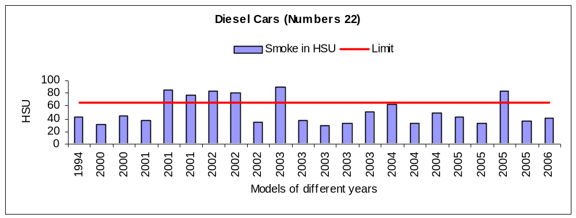B. Diesel light duty vehicles
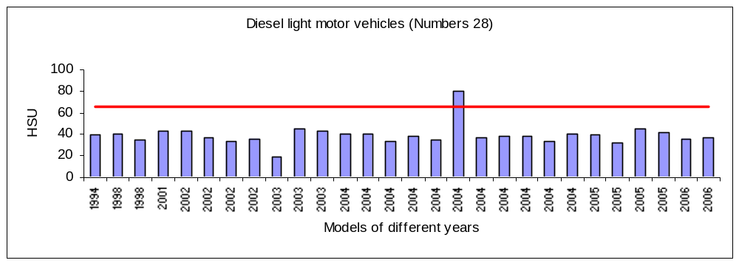Source: According to data submitted by the Delhi transport department to EPCA during January 2007

Diesel NOx emissions measurement in in-use vehicles programme is not common globally. These tests are very expensive and also very complicated for in-use application. But California is still looking at the possibility of introducing NOx measurement for in-use application to ensure that repair to correct high smoke emissions does not cause higher NOx emissions. Australia that has introduced more advanced smoke tests and also particulate measurements in in-use diesel vehicles has a small programme of NOx measurement, and Oregon in the US also has a programme for diesel light duty vehicles. This essentially means, globally there is barely any system to track in-use NOx emissions. It is also not clear what impact maintenance has on diesel NOx emissions that are inherently high and normally remain stable during in-use operations.

6.1 Vulnerable to corruption
It is also a cause of great worry that the smoke opacity test for diesel vehicles despite the recent improvements can be easily fudged. For maintaining accuracy, the test are being conducted when the maximum governed engine speed — measured as rpm — is reached and the engine is sufficiently warmed up. But EPCA’s recent random survey of PUC centers in June-July 2006 showed how some of the PUC centers are still indulging in fudging during tests.

A team comprising of inspectors from Delhi transport department and representative of Centre for Science and Environment had carried out a decoy operation on June 28, 2006 and unearthed gross irregularities in PUC testing of diesel vehicles. The team found that diesel PUC test certificate was issued without even starting the engine. The operator managed to generate RPM data and smoke readings by manipulating with the RPM sensor and the smoke meter. Delhi transport department has already taken action against the PUC center and closed the centre.

Even though there is an overall improvement in implementation of PUC programme in the city, diesel tests continue to remain a problem. Urgent steps are required to improve its overall effectiveness.

7. Global experiences with diesel

In the European Union the Euro I emissions standards were enforced in 1992 and Euro II in 1996, Euro III in 2000 and Euro IV in 2005. In relation to this time line India that currently follows Euro II emissions standards is 10 years behind Europe and only eleven Indian cities that have enforced Euro III standards are five years behind Europe. The implication of this time lag for diesel car emissions is particularly ominous as the European norms are lagging behind the world’s best standards. And India is far behind Europe.

Estimates show that the current US Tier-2 NOx and PM limit values for light-duty vehicles are approximately 80 per cent tighter than the current Euro IV car limits. Similarly, new US limits for heavy-duty vehicles are approximately 90 per cent tighter for NOx and 60 per cent tighter for PM than the future European heavy-duty Euro V limits. European norms are still not close to achieving the fuel neutral status of the US norms for light-duty vehicles. In the US the norms are uniformly stringent for all vehicles irrespective of the fuel they use. The US norms do not make any special allowance for diesel cars as opposed to the practice in Europe. Even in 2014 European NOx norms will remain more lax than the current US norms.

Europe, without tightening the emissions standards significantly, has additionally set stringent CO₂ emissions targets that the European car industry had volunteered to meet. In 1999 the car manufacturers have committed to a voluntary agreement to reduce new passenger vehicle CO₂ emissions to 140 gm/km target by 2008 — an approximately 25 per cent reduction from 1995 levels. Though this mandate led to significant fuel economy improvement in European vehicles, the European carmakers have also relied heavily on increasing the share of diesel vehicles to meet the fleet-wide target. As diesel cars are comparatively more fuel-efficient than petrol cars, increasing their share helped to lower the average fleet wide CO₂ levels. This tendency in combination with cheaper diesel prices and weaker emissions regulations has caused a major shift towards diesel cars in Europe. Currently in Europe half of the new cars sold are diesel.

As a result of such high numbers of diesel cars meeting lax emission standards some European cities are at risk or are already violating air quality targets for NOx and PM10. In fact, Europe has recently revised their ambient air quality guidelines. Accordingly, the PM10 standard (24 hourly average standard of 50 microgrammes per cubic metre) must not exceed on more than 35 days in a calendar year. Many European cities like Munich, Stuttgart, Dusseldorf, Berlin, exceed the air quality standards and the civil society has begun to drag the city authorities to Court.

Concern over diesel emissions has led countries like Germany to launch clean diesel campaign and mandate fitment of particulate traps along with diesel fuel with sulphur content as low as 10 ppm. But Europe has not yet been able to solve the problem of NOx emissions. Due to the primacy attached to fuel economy and the attendant problem of CO₂ emissions diesel cars are now getting caught in the trade-off between NOx and fuel efficiency. While the future PM emissions norms under Euro V and Euro VI will close gap with the US standards, the NOx norms continues to remain comparatively lax.

This is because meeting equally stringent NOx levels and tight fuel efficiency target present a difficult engineering challenge in diesel engines. Additional NOx control technologies in the form of de NOx catalyst that are needed to reduce NOx further are still in the making and large scale commercial application has not been possible yet.

Therefore it is important that India recognises the inherent flaws of the European norms and not repeat the mistake. We cannot afford to allow the problem to grow and then deal with the pollution aftermath. It is important to be precautionary and stem the tide at the early stages of dieselisation.

Box:
What countries are doing to make emission standards neutral?

The US, California and Japan, have leapfrogged their emissions standards to phase in the clean diesel fuels and technologies. This includes diesel fuel with sulphur content less than 10 to 15 ppm along with advanced exhaust after-treatment devices.

The particulate norms for diesel cars in Europe will close gaps with the US and Japan only in 2009 when Euro V will be enforced. European NOx norms will catch up with Japan only in 2014 when Euro VI norms are expected to be enforced. But even then it will trail behind the current US norms by at least 43 per cent. By any measure India is far behind the industrialized nations which are tightening their standards. Indian metros and other big cities (11 total) are meeting the Euro III norms, which was enforced in Europe in way back in 2000. (See graph 8: Emission norms in EU, US and Japan). Given this situation, there is no way that we can call diesel vehicles in India, meeting our current emission norms, as ‘clean’.

Graph 8: Emission norms in EU, US and Japan
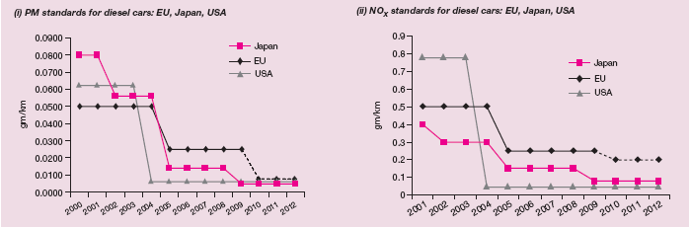
Note: Indian metros are currently following the Euro III emission norms that were enforced in EU in 2000. In 2005 Europe has moved ahead to enforce Euro IV emission norms.
Sources: Proposed Euro V limit values for diesel passenger cars, European Commission, Brussels; Future Diesel: Exhaust gas legislation for passenger cars, light-duty commercial vehicles and heavy-duty vehicles, Federal Environmental Agency, Germany; International Council on Clean Transportation.

8. Indian fiscal policies that ‘promote’ diesel

In India, the price of diesel fuel is kept lower than petrol, which is heavily taxed. The price of diesel is kept lower on the grounds that this fuel is required for use by agriculturists, goods transporters and public bus systems in cities. The price is also kept lower than petrol, as it is argued that adulteration with kerosene, already rampant, will become even more so, if the price of diesel is increased. In other words, separate pricing policy has not been framed for diesel to be used in private automobiles. This price differential, assisted by the tax exemptions provided by government, is now leading to increasing use of this “poor” person’s fuel by the richest car owners.

While government has never made this policy explicit, its actions have in fact encouraged the use of diesel, without concurrent policies that would manage its pollution fall-out.

For instance, the 2006 Union budget allowed reduction in the excise duty for “small cars” from 24 per cent to 16 per cent. But to make special allowances for diesel vehicles to qualify for this exemption it expanded the definition of the ‘small’ car to 1,500 cc. This relaxed definition of small diesel cars has further accelerated sales of these vehicles.

In addition, the price differential between petrol and diesel fuel is also leading to increased sale of polluting diesel jeeps and sports utility vehicles (SUV’s). The SUVs are much indicted by pollution regulators, because they are more polluting than smaller cars.

India is therefore, ‘allowing’ diesel vehicles without any policy framework. Other governments such as Europe, Japan, the US, California have taken multi-pronged approach – they have set tight fuel economy regulations along with stringent emissions standards. These governments also do not allow the price differential between petrol and diesel to be so wide as to force consumers to make choices in favour of one. Prices of diesel and petrol are comparable across the world.

India is losing out on all fronts.

Our diesel vehicles are not even fuel efficient. The most efficient small diesel car is 20-30 per cent less fuel-efficient than its counterpart in Europe. Our diesel vehicles are more polluting. The most ‘clean’ diesel car is 50 per cent more polluting than their counterparts in Europe. Similarly, Europe and other parts of the world are phasing in one of the cleanest diesel fuel (10 ppm sulphur) and emissions standards and mandated fuel economy standards.

9. Recommendations and directions sought

It is important to note that significant steps have been taken in the last few years to combat air pollution in Delhi. These include the implementation of one of the largest ever CNG programme in the world. These mitigation efforts have helped to stabilise particulates and substantially lower sulfur dioxide and carbon monoxide levels in Delhi’s air. But uncontrolled dieselisation can undo these gains and also have adverse public health impact.

In view of the serious public health challenge that the diesel cars present EPCA has repeatedly drawn attention of the Hon’ble Court to the need for curbing this problem. In 2001, EPCA had stated that only ‘clean’ diesel technology that runs on diesel fuel with sulphur content less than 10 ppm and is fitted with advanced emissions control devices like particulate traps can be allowed in the city. But even six years later this has not been implemented. But industry has continued to produce intermediate technologies with serious public health consequences.

The lower price of diesel as compared to petrol provides the impetus for the sale of these vehicles. In this circumstance, EPCA has no option but to recommend to the Hon’ble Court, the need to stop the use of diesel in personal transport vehicles in the city of Delhi. This restriction should also be applied to vehicles entering the city from neighbouring states as otherwise, the influx of these vehicles into the city will continue to grow and will negate the gains of pollution control measures.

Annexure 1

Health Studies

- Particulate air pollution and morbidity in the California Central Valley, 2002: A strong and consistent increase was observed in the rate of hospitalisations and/or emergency room visits for acute or chronic respiratory conditions associated with exposure to PM2.5 (particulate matter less than 2.5 micron in size). Every 10 per cent increase in the level of PM2.5 was associated with a 4.1 per cent increase in acute respiratory hospitalisations, a 7.5 per cent increase in chronic respiratory hospitalisations, a 5.2 per cent increase in acute respiratory emergency room visits and a 6.5 per cent increase in chronic respiratory emergency room visits.

- National Environmental Trust study in 2002: This calculates the cancer risk to children in the five most populated air basins in California. The report found that exposure to diesel particulate matter (DPM) will cause infants to reach the US Environmental Protection Agency’s (USEPA’s) one-in-one-million lifetime cancer limit in 17-32 days, depending on the air basin they live in. By the age of one, children will have exceeded this benchmark by 11 to 21 times, and by age 18, by 121 to 252 times. Adults reach the USEPA’s one-in one million lifetime cancer limit in 35-71 days from exposure to DPM. The California Environment Protection Agency’s (EPA) cancer unit risk estimates were used in this study.

- US Public Interest Group (US PIRG) report in 2002: This estimates the lifetime excess cancer risk to the US public from hazardous air pollutants. The report was based on population exposure levels from the EPA’s National Scale Air Toxics Assessment (NATA) report, and DPM toxicity estimates from the California EPA. The report concluded that throughout the US the lifetime excess cancer risk from breathing hazardous air pollutants was one in 1,200, with DPM accounting for 89 per cent of this risk. Of the cancer risk from breathing DPM, 32 per cent was from emissions from on-road sources, and 68 per cent from off-road sources.

- World Health Organization (WHO) used four different studies: The studies were about the carcinogenic impact of diesel exhaust on rats. WHO used them to estimate unit risk values for cancer. Its conclusion was that the lifetime excess cancer risk ranged between 1.6 and 7.1 in 100,000 excess cancer cases per every microgramme per cubic metre of DPM.

- Puget Sound Clean Air Agency’s draft report in 2002: This compared local air toxics monitoring data with data from the EPA’s NATA modelling estimates for the Puget Sound region. The review confirmed the NATA modelling data and concluded that DPM accounted for 70 to 85 per cent of the total excess lifetime cancer risk from all air toxics, with mobile sources of DPM contributing 85-95 per cent.

- California’s South Coast Air Quality Management District released the results from its Multiple Air Toxics Exposure study (MATES-II) in 1999: MATES-II was a comprehensive urban air toxics monitoring and evaluation study. Using the California EPA’s lifetime excess cancer unit risk is three in 10,000 people per one microgramme of DPM per cubic metre. The study concluded that diesel was responsible for 70 per cent of the excess lifetime cancer risk, leading to an added average lifetime cancer risk of 980 in one million from exposure to DPM.

- As part of the Diesel Risk Reduction Plan to reduce PM emissions from diesel-fuelled engines and vehicles, California Air Resources Board (CARB) compared the lifetime excess cancer risk from diesel particles with the cancer risk from the top 10 air toxic risk contributors, using exposure information from its statewide air toxics monitoring network, and the California EPA’s cancer unit risk estimate. CARB’s conclusion was that exposure to air toxics in the state resulted in an average excess lifetime cancer risk of 758 in one million, and that diesel particles were responsible for more than 70 per cent of this added lifetime cancer risk.

- US-based Natural Resource Defense Council study in January 2001: It points out that schoolchildren suffer from sustained exposures to diesel exhaust while travelling in school buses for one-two hours every day during a school year of 180-200 days over a schooling period of 10 years. It concludes that a child riding a diesel school bus is being exposed to as much as 46 times the cancer risk considered significant by the USEPA.

Table: Diesel is Carcinogenic
2002 | US Environmental Protection Agency | Likely human carcinogen
2001 | American Council of Government Industrial Hygienists (proposal) | Suspected human carcinogen
2001 | US Department of Health and Human Services | Reasonably anticipated to be a human carcinogen
1998 | California Air Resources Board | Toxic air contaminant
1996 | WHO International Programme on Chemical Safety | Probable human carcinogen
1995 | Heath Effects Institute | Potential to cause cancer
1990 | State of California | Known to cause cancer
1989 | International Agency for Research on Cancer (IARC) | Probable human carcinogen
Source: January 2004, Patricia Monahan and David Friedman, The Diesel Dilemma, Diesel’s role in the race for clean cars, Union of Concerned Scientists

References:
1. Jacqueline Sharp 2003, The public health impact of diesel particulate matter, Sierra Club of Canada, Toronto, p 21-28
2. Gina M Solomon et al 2001, No breathing in the aisles: diesel exhaust inside school buses, Natural Resources Defense Council, Cambridge,
USA

Asif Faiz et al 1996, Air pollution from motor vehicles: standards and technologies for controlling emissions, World Bank, Washington DC, USA, p 63
Michael Walsh et al 1997, Clean fuel for Asia: technical options for moving toward unleaded petrol and low-sulphur diesel, Technical paper No 377,World Bank, Washington DC, USA
Anon 1998, ‘Appendix III, part A: exposure assessment’, Proposed identification of diesel exhaust as a toxic air contaminant, California Environmental Protection Agency, Sacramento, USA
Michael Walsh and Charlotte J Pera 2003, Progress towards clean cars, trucks, and buses, International Council on Clean Transportation, San Francisco, The Hewlett Foundation and The Energy Foundation, San Francisco, USA, p 49
Anon 2004, Towards cleaner urban air in south Asia: tackling transport pollution, understanding sources, Energy Sector Management Assistance Programme of World Bank and United Nations Development Programme,Washington DC, USA, p 71
Anon 2004, The emission reduction potential of low-sulfur diesel fuel in Asian countries, Enstrat International Limited, UK
Anon 2004, The emission reduction potential of low-sulfur diesel fuel in Asian countries, Enstrat International Limited, UK,
Anon 2004, The emission reduction potential of low-sulfur diesel fuel in Asian countries, Enstrat International Limited, UK,
Anon 2004, The emission reduction potential of low-sulfur diesel fuel in Asian countries, Enstrat International Limited, UK,
Michael Walsh 2003, ‘Motor vehicle pollution and fuel consumption in China: the long-term challenges’, Energy For Sustainable Development, Vol 7, No 4, December,
Anon 2002, Subtracting sulfur: reducing diesel sulfur levels to reduce urban pollution, Clean air and energy: transportation: in-depth policy paper, Natural Resources Defense Council, New York, USA
Fuel choices of transport and the environment, The Energy and Resources Institute, Delhi, February 2004
Motor Vehicles Laws 2004, The Central Motor Vehicles Rules, 1989, Universal Law Publishing Co Pvt Ltd
Emissions data provided by Automotive Research Association to Centre for Science and Environment, June 21, 2002, mimeo
Michael Walsh and Charlotte J Pera 2003, Progress towards clean cars, trucks, and buses, International Council on Clean Transportation, San Francisco, The Hewlett Foundation and The Energy Foundation, San Francisco, USA,
Michael Walsh and Charlotte J Pera 2003, Progress towards clean cars, trucks, and buses, International Council on Clean Transportation, San Francisco, The Hewlett Foundation and The Energy Foundation, San Francisco, USA,

